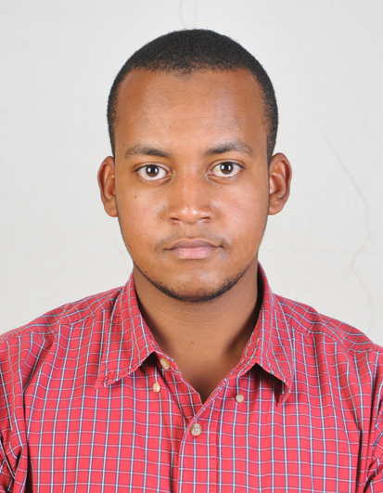
Eng: Elhadi Mohsin Hassan Abdalla
Research Assistant, the Hydraulic Research Center, the Ministry Of Water Resources and Electricity, Sudan

Personal Data

GENDER: | Male.
NATIONALITY: | Sudanese.
DATE OF BIRTH: | Nov. 16nd 1992.
PLACE OF BIRTH : | Wad madani , sudan.
MARITAL STATUS: | Single .
LANGUAGES:​ | Arabic (Mother tongue)  English (Very good speaking and writing).
E-MAIL ADDRESS:​ | Alhadimohsin@hotmail.com
Telephone | +249910303186  +249116747717
Address | House No. 28A, Square 4,Hey Elmatar, Khartoum, Sudan

Academic Background:

2009-2014: BSc (FIRST CLASS ) Honours Degree in Civil Engineering – Khartoum University, Sudan .
Graduation Project:
Simulation Model of Dams System in Atbara River.
The objective of the research is to Create a model (using Visual basic programming language) .
The Function of the model is to use the concept of water balance to develop new operation roles to Atbara River dams (Khasm Algebra, Setiet and Upper Atbara)

Current Position :-
Research Assistant at HRC “HYDRAULIC RESEARCH CENTRE, MINSTRY OF WATER RECOURSES AND ELECTRICITY, SUDAN “from 9/11/2014.

Skills & Qualifications :

Computer skills:
- Microsoft office (Excel, word, PowerPoint).
- Programming languages: (Visual basic, FORTRAN and Matlab).
- ARC GIS.
- AUTOCAD .
- SOBEC .
- Google earth .

Other Skills:

- Hydrological data processing using Excel , GIS, Google earth ,
- Dams Modeling using visual basic & sobec.
Involving Project:
The impact of Grand Ethiopian Renaissance Dam (GERD) on the flood plain agriculture in Sudan

Field Experience;

University Field training:

- 2011: (Al-SBLOGA) – Khartoum, Sudan. Training in Survey works, (1 week)
- 2011: (AL-MKABRAB irrigation scheme) – (1 day).
- 2013: ( KHASHM ELGERBA dam, SETIET AND UPPER ATBARA dam, ALGAZIRA irrigation scheme) – (3 days).

HRC Field Work:
- 2014 : GAZIRA SCHEME , Data collection for cross sections using GPS .
- 2015 : Data collection for Main Nile cross-sections from (Al-SBLOGA to ATBARA) using GPS and ECOSOUNDER.

Personal Statement:

I can adapt easily to new environments and people of diverse backgrounds, having team work spirit, honesty and loyalty, ability to work under minimum supervision, ambitious, confident, cooperative and Patient. As an engineer I believe that I should be equipped with strong mathematical background and excellent computational skills.

References:

- Dr. Adel Mohammed Alkhidir , Graduation project Supervisor, University of Khartoum
Tel: 0123047907
- Dr. Magdi zumrawi , Head of Civil Engineering Department , University of Khartoum
Tel:

